*Type of Article (e.g. Regular Research Article, Review Article, Special Section on …….)*

**Study Of The Effectiveness Of Subsea Pipeline Leak Detection Methods**

**Abstract**

|  |  |
| --- | --- |
| The oil and gas exploration and production sector plays a crucial role in the global economy, with undersea pipelines providing the safest and most cost-effective means for transporting natural gas and crude oil from offshore locations to the mainland. Nonetheless, undersea pipeline systems are susceptible to leaks, which can lead to significant financial losses and severe environmental damage. Thus, it is vital to monitor these pipelines to quickly identify leaks or even foresee them, thereby minimizing the repercussions of oil spills on society. A variety of leak detection techniques have been created, and further study is required to pinpoint research deficiencies for future endeavors. There are numerous approaches for identifying pipeline leaks, each possessing its own set of benefits and drawbacks. External methods are typically more precise in locating leaks, whereas internal or computational techniques can assess the severity of the leaks. The acoustic technique is regarded as the most effective for evaluating subsea pipelines and identifying leaks. However, every method has its own advantages and limitations that need to be taken into account before selecting the appropriate technique. Developments in computational technology have also facilitated the increased adoption of dynamic modeling methods in the oil and gas sector. Additional considerations, such as cost, sensitivity, accuracy, user-friendliness, and the specific type and positioning of the pipeline, must also be factored into the decision-making process for selecting an appropriate pipeline leak detection method. | **Hamzah**  Department of Naval Architecture, Hasanuddin University, Indonesia  Correspondence author:  Hamzah_amda@unhas.ac.id  Tel.: +62 812-4420-9266 |

**Keywords:** Detection, Monitoring, Pipe Leak, Subsea Pipeline



1. **Introduction**

Exploration and production of gas and oil have a significant positive impact on the world economy. Undersea pipeline networks are the fastest, safest, and most economical way to link offshore oil and gas resources with the entire onshore oil and gas production management system. They are considered the "lifeline" of offshore oil and gas engineering. The expansion of oil and gas in deep water and even ultra-deep water has created major challenges for the construction of underwater pipeline networks. [1]. Pipelines are the safest and most economical means of transporting crude oil and natural gas from offshore to onshore processing facilities for use in homes and businesses. However, breaches in pipeline networks can result from a variety of factors, such as corrosion and external influences [2].

However, the risk of serious mishaps brought on by pipeline collapse is rising as the use of mile-long pipelines to transport hazardous materials has grown in popularity globally in recent decades. Failure can be caused by deliberate (like vandalism) or inadvertent (like corrosion and damage to devices or materials) factors, which leads to pipe failure and consequently irreversible harm, including monetary losses and severe environmental contamination, primarily in the absence of a leak. quickly identified [3]. A pie chart in Figure 1 shows the statistics of the main reasons why pipes fail, including pipe corrosion, human mistake, installation and erection work flaws, manufacturing flaws, and external factors.



**Figure 1.** Pie chart of statistical data on damage to pipes[3]

Pipeline leak incidents are difficult to prevent given the numerous potential causes of failure. However, to lessen the impact of oil spills on communities, it is essential to closely monitor pipelines for timely leak detection or even anticipate possible leaks, as early recognition of leaks enables rapid actions to stop oil discharge and maintain pipelines effectively. As a result, it is possible to minimize losses, injuries, and other significant social and environmental impacts associated with pipeline failures. Leakage occurrences still arise in steel pipes due to factors such as internal and external corrosion, stress corrosion cracking, mechanical damage, manufacturing flaws, structural defects, and various operational issues. To effectively manage and reduce fluid loss, leak detection in transmission systems must acknowledge that the integrity of pipelines is crucial for safe operations. Delays in detecting leaks can result in property damage and loss of life due to fire hazards and depletion of valuable resources.

To discover leaks, we have conducted many leak detections. These include real-time transients, fiber optic cable systems, video monitoring, pressure monitoring, negative wave pressure, and more. The approaches that are currently in use can be broadly divided into two categories: visual/inspection methods and external and internal/computation-based methods.

Leak detection in the transmission must take into account that the pipeline is required for safe operation in order to regulate and reduce fluid loss. Due to the risk of fire and the loss of precious commodities, delays in leak identification result in property damage and fatalities. Leak detection techniques are primarily used to help pipeline controllers find and identify leaks. Reviewing the body of existing literature, examining the development of different approaches, and identifying research needs for further investigation are the objectives of this work.

1. **Theory And Methodology**

This study employs a systematic literature review to explore the diverse techniques for detecting and monitoring leaks in underwater pipelines, aiming to pinpoint the most effective methods currently in practice. Throughout the years, numerous approaches for leak detection have been proposed, each founded on distinct principles and strategies. The techniques available for leak detection encompass acoustic emission, fiber optic sensors, ground penetrating radar, harmful pressure wave analysis, pressure point analysis, dynamic modeling, vapor sampling, infrared thermography, digital signal processing, and mass volume balance. Researchers have categorized these methods using various frameworks. Some have primarily divided them into two main groups: hardware-based and software-based techniques. Further examination has resulted in the classification of current leak detection systems into three major categories: internal methods, non-technical or non-continuous methods, and external methods. This research will arrange the various techniques into two main categories: exterior, visual, or biological methods, and interior or computational methods. A comprehensive classification of these techniques is illustrated in Figure 2. The exterior method utilizes a range of artificial sensing systems to aid in the detection process external to the pipeline.

Additionally, biological approaches use the visual, auditory, and olfactory sensitivity of trained dogs or expert personnel to detect leaks. Additionally, interior options include software-based methods that use sensors that monitor the internal pipe environment for detection tasks along with the intelligence of computer algorithms. Helicopters, drones, smart pigging, and autonomous underwater vehicles (AUV) can all be utilized to transport cameras or sensor equipment to designated locations for remote surveillance [3].



**Figure 2.** Classification Chart of Pipe Leak Detection Methods[7]

* 1. Methods Based Outside the Company
     1. Acoustic Techniques

Acoustic emission is a method that leverages the sounds or vibrations generated from the rapid release of energy at a specific point in the material to identify leaks in pipelines. This technique detects the elastic waves produced by high-pressure fluids escaping due to a rupture during a leak, which can be captured in a frequency range that may extend up to 1 MHz. By analyzing the differences in the arrival times of the acoustic signals picked up by two sensors, it is possible to pinpoint the exact location of the leak. Acoustic leak detection techniques can be categorized into active and passive types, with three primary kinds of acoustic sensors: aquaphones, geophones, and acoustic correlation methods. Acoustic emissions offer an effective, non-invasive solution for locating pipe leaks, aiding in the reduction of environmental harm and conservation of resources.

The fundamental concepts of acoustic techniques involve the detection and analysis of acoustic signatures generated by the escape of a pressurized substance through flowing fluid or pipe walls. The signals can undergo filtering through wavelet analysis and packet decomposition to isolate a range of leakage signals. Methods such as cross-correlation functions, adaptive filtering approaches, and multi-modal sensing can be employed for leak detection. Innovative advancements like acoustic methods integrated with twin ball technology have been suggested for both leak detection and pipeline self-healing. Additionally, the PCA-SVD diagnostic model and EMD technology have also been recommended. Nevertheless, the efficacy of acoustic methods can be influenced by factors such as the positioning of sensors, rapid attenuation of signals, and environments with high levels of noise. Kotsiopoulos et al. (2022) introduced a methodology for locating leaks based on segmented acoustic vibration signals analyzed in both time and frequency domains. They determined the leak location by utilizing a time-of-arrival difference algorithm alongside statistical analysis.

* + 1. Fiber Optic Sensing Cable

This method for detecting leaks in pipelines utilizes fiber optic sensors distributed along the entire length of the pipeline. These sensors can be configured as either distributed or point sensors to monitor different physical and chemical characteristics of hydrocarbon leaks along the pipes. The fundamental principle of this system is the change in temperature of the cable when a leak occurs, as hydrocarbon fluid infiltrates the cable's coating. By monitoring temperature fluctuations within a fiber optic cable, irregularities along the pipeline can be identified. Distributed Fiber Optic Sensors (DOFS) collect environmental data through three types of pem scattering: Raman, Rayleigh, and Brillouin. This categorization is determined by the frequency of the optical signal, as shown in Figure 3. Brillouin scattering can assess both voltage and temperature but is particularly sensitive to variations in voltage. On the other hand, Raman scattering solely responds to temperature, providing enhanced temperature measurement accuracy with a resolution of 0.01 °C or better.



**Figure 3.** Classification of scattering measurements [4]

Distributed temperature sensing (DTS) utilizes temperature changes that occur in fiber optic cables when there is a leak in the pipe. The accuracy of leak detection systems increases over time because gaseous ammonia leaks cause a decrease in temperature as the number of leaks increases. Several studies have used this technology to detect pipe leaks using fiber optic-based leak detection systems, such as the Brillouin fiber optic sensing system and the FBG fiber optic sensor system. However, fiber optic cable distribution cannot determine the leak rate or total number of leaks. However, this system can determine the leak point with an accuracy of up to 1 meter from the leak point and can detect leaks along the entire length of the cable laid along the pipe. Distributed fiber optic technology continues to develop to improve the accuracy and stability of leak localization[4].

* + 1. Vapor Sensing Tube

A vapor sensing tube is an effective tool for measuring the level of hydrocarbon vapor present in a pipe's environment. It can be utilized to identify gas emissions released into the surrounding area. The gas concentration within the tube environment can be assessed over a duration of pump time, with the level of absorption serving as an indicator of the severity of the oil spill. Several types of vapor sampling-based leak monitoring systems for pipes have been suggested in academic literature, including sniffer tubes and sensor hoses installed beneath pipes. While vapor sampling offers benefits in identifying minor leaks, factors such as concentration gradients and the longevity of the system can limit its overall efficacy. The benefits of vapor sensing tubes include the ability to detect minor leaks, functioning independently of pressure or flow balance, and delivering exceptional performance in leak detection for multiphase flow situations.

The sensor is also capable of withstanding high hydrostatic pressure. The response time is one of this technique's primary drawbacks, though. The average response time for a leak is a few hours to a few days. Consequently, faster reaction times can be achieved by integrating vapor sensors with additional leak detection techniques.

* 1. Visual/Inspection Methods

Traditional methods for detecting pipeline leaks involve trained personnel, dogs, intelligent pigging, and helicopters/drones, which can only be applied to shallow onshore or offshore pipelines. The recent development of remotely operated vehicles (ROVs) and autonomous underwater vehicles (AUVs) has changed the operating style of offshore oil transportation operators, making them suitable for inspections in remote and dangerous environments. This system has the advantages of being remote, lower maintenance costs, and higher operating security. However, it has disadvantages, such as high purchasing or hiring costs, adverse weather conditions, and legal constraints. However, significant efforts have been devoted to underwater robotic navigation and sensing research to realize fully autonomous AUVs for pipeline inspection and monitoring tasks with minimal human intervention. UAV/Drones/Robots. Various AUVs and ROVs are shown in figure 4.

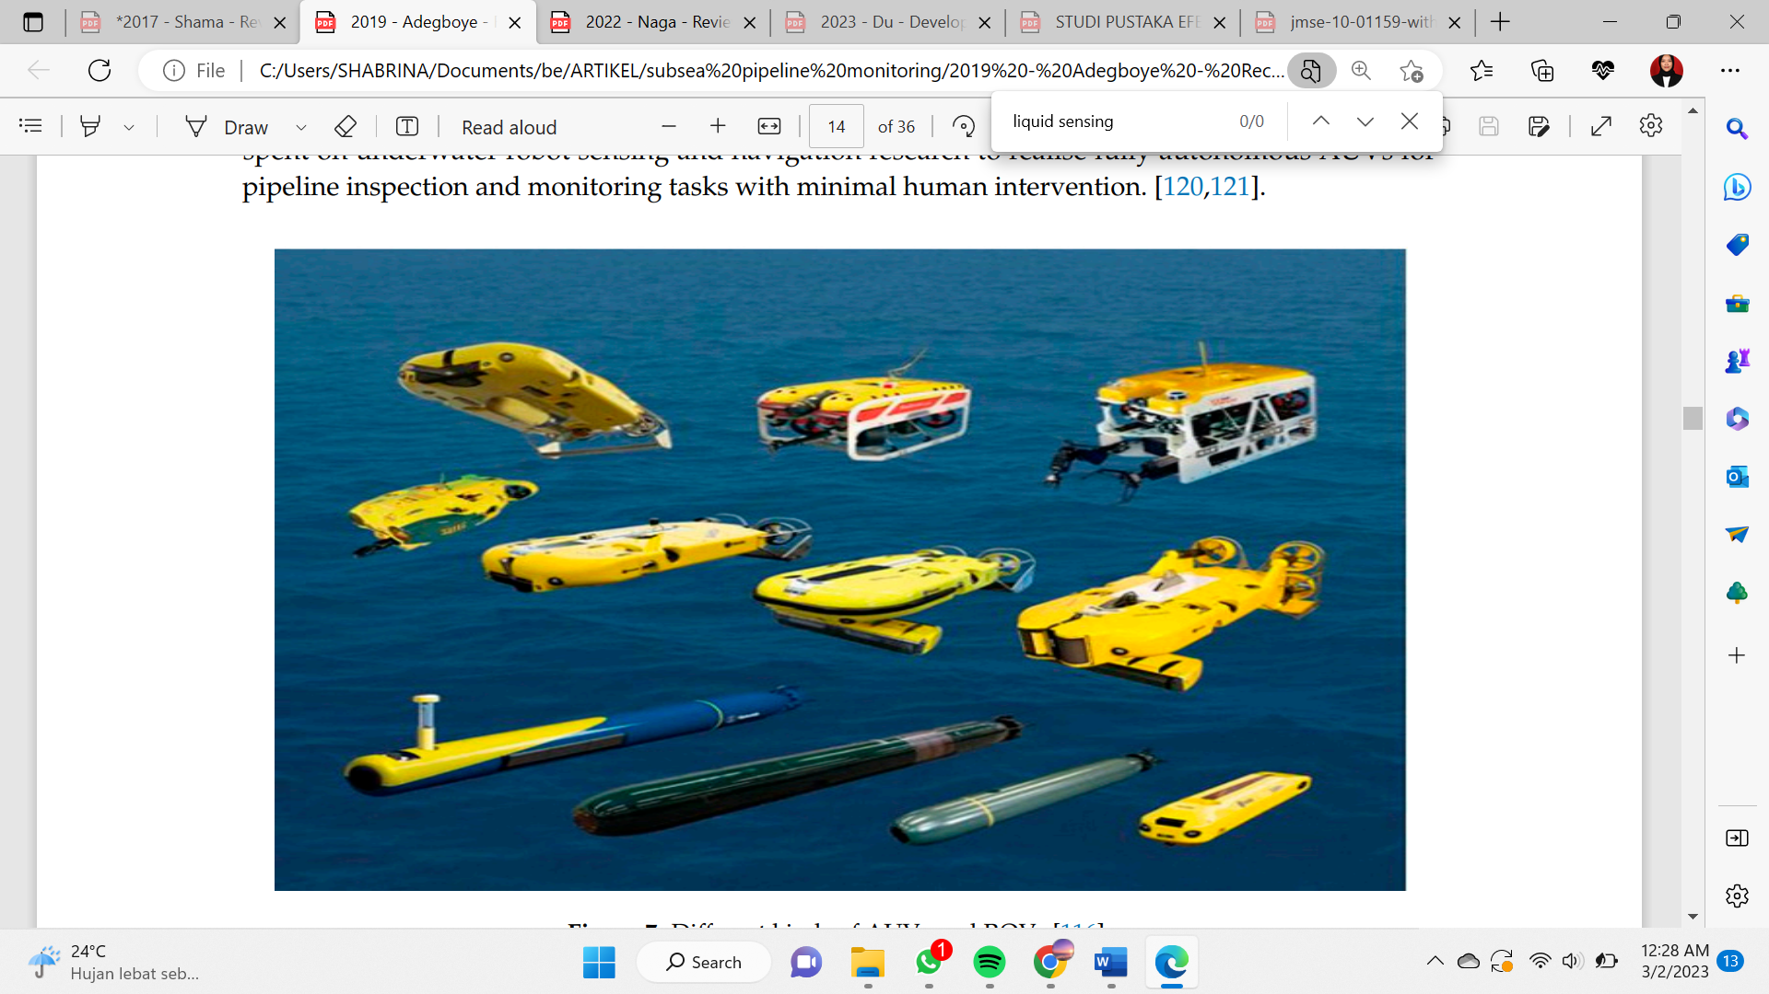

**Figure 4.** Types of AUV and ROV

To guarantee safe and dependable operation, practical methods for keeping an eye on bolted connections in oil pipeline systems are crucial. Several research have shown that it is feasible to use vision-based assessment methods for pipeline monitoring, and they have been recommended for real-time bolt looseness detection. To increase this method's resilience, more research is necessary, particularly with regard to online training and the inclusion of bolt looseness in big flag bolt sets. All things considered, creating trustworthy and efficient monitoring methods for joint flange Whichmade is essential to guaranteeing the secure and effective operation of oil piping systems.

* 1. Methods Based on Internal Computations
     1. Balance of Mass and Volume

To enhance leak detection techniques, Gajbhiye (2008) suggested a mechanistic modeling approach that integrated mass balance with local steady-state multiphase Beggs and Brill flow correlation. Under fixed pressure limit settings, this mechanistic modeling enables the real-time monitoring of variations in total intake and exit outflow as indicators for potential leak identification. The most basic leak detection technique is volume balance, which looks at the volumes entering and leaving a pipe over time. Simple volume balancing techniques, however, cannot be used for shorter periods of time and are insensitive to compressible fluids. It has been shown that Mactaggart's (1989) corrected volume balancing methodology is 100% accurate for a sour gas leak detection system when paired with the proper pipe equipment [3].

According to the principle, a fluid that enters a pipe section stays there until it leaves [11]. It is possible to measure the fluids entering and leaving conventional networks of cylindrical pipes. If there is no leak, the inflow and outflow measured at the pipe segment's two ends are regarded as being evenly balanced. In this way, the difference between the mass-volume flow measured at the two ends will indicate a leak.

The oil and gas sector has widely embraced and marketed this technique. Orifice plates, positive displacement, turbines, and mass flow devices are some of the several kinds of flow meters that are utilized. However, there are a number of drawbacks to this approach, including the instrument's intrinsic ambiguity, its vulnerability to sporadic disruptions and the dynamics of pipeline networks, and its incapacity to pinpoint leak locations. Nonetheless, the system's efficacy will be enhanced by a combination of mass balancing and other leak detection methods, and leak site localization can be accomplished by expanding the number of monitoring devices throughout the pipeline [3].

* + 1. Negative Pressure Wave

When a leak occurs in a pipe, there is a sudden drop in pressure at the site of the leak, resulting in rarefaction or a negative pressure wave that travels both upstream and downstream. Pressure transducers placed at each end of the pipe segments can capture these pressure waves. To identify a leak, leak detection algorithms must process the pressure data collected from these transducers. Different methods, including support vector machine learning, have been applied. The time lag between the detection of the damaging pressure wave by the two pressure transducers at either end can help pinpoint the leak's location. If the leak is nearer to one end of the pipe, that end's transducer will detect the pulse first, and the duration for the pulse to reach the other end can inform an accurate leak location. Systems for detecting leaks based on harmful pressure waves, such as ATMOS Wave, can also provide estimates of the size of the leak.

The signals produced by minor leaks within pressure waves can easily become blended with surrounding noise and other interferences, complicating the accurate detection of these signals and the identification of oil spills. A suggested approach for identifying minor leak signals employs enhanced wavelet harmonics, as indicated in [13]. This technique aims to disentangle the pressure wave signal from environmental noise; however, it faces limitations regarding how rapidly the signal diminishes in intensity over time. To address this challenge, the authors apply a window function to smooth the wavelet harmonics. Various methods to mitigate the influence of background noise on leakage signals have been investigated in previous studies. An independent component analysis (ICA) technique designed to distinguish unique signatures from pressure wave signals obscured by background noise is detailed in [14]. Additionally, another study introduced a more sophisticated ICA technique for accurately isolating oil pipeline leak signals [15]. This method is based on statistical estimation and iterative estimation strategies derived from information theory.

In [16], a different approach to finding tiny leaks is shown by employing a morphological filter that has been specially created. A morphological filter retains the fundamental geometric characteristics of the pressure signal while eliminating background noise. In [17], a time-inverse pipeline leak localization method with a modifiable resolution mechanism is suggested. A time interval for resetting the leak localization resolution is formulated using the suggested methodology. In [18], a proposal was made to conduct an experimental investigation of leak localization using dynamic pressure waves. In that study, a theoretical propagation model of dynamic pressure waves was built and an enhanced wavelet transform method was developed.

* + 1. Pressure Point Analysis

In this framework, pressure readings are tracked to assess operational behaviors within the pipeline. Various parameters are compared to historical trends established through statistical evaluations of previous pressure data, triggering an alert if any irregularities are detected. For pipelines that transport single-phase fluids, pressure trend monitoring systems can detect significant leaks more quickly than the Mass Balance Compensation on Packet Lines (MBL PC), although they have a lower effectiveness in detecting leaks. To identify two-point leaks based on the fluid and piping characteristics in parallel systems, Fu et al. (2022) proposed a method that combines flow parameter analysis with computational fluid dynamics (CFD) simulations and experimental validation by relating pressure drop, leak position, and flow rate through a mathematical model. The problem of inaccurate signal positioning, which may lead to false alarms, is tackled with an improved signal denoising technique that utilizes cross-spectral analysis together with ensemble empirical mode decomposition (EEMD), a method that considers infrasound and damaging pressure waves (Meng et al., 2022). This denoising approach produces better results in comparison to wavelet denoising and EMD denoising techniques.

This method is considered one of the fastest ways to detect leaks in pipes because a leak always results in a direct pressure drop at the leak point [3]. Pressure point analysis (PPA) is a type of pressure trend monitoring combined with an MBL PC equipped with a vapor sensing system. The advantages of this system are: 1) Low installation and instrumentation costs. 2) The combination of these two systems is complementary. 3) Faster leak detection compared to other systems. However, this system has several weaknesses: 1) The possibility of false alarms because a decrease in pressure in the pipe is not a unique event for leaks. Therefore, this system is limited to detecting medium or large leaks. 2) The leak location is determined based on pressure data with time stamps between two measurements at the pressure transmitter location [12].

* + 1. Processing Digital Signals

Digital signal processing techniques use extracted data, such as amplitude, wavelet transform coefficient, and other frequency responses, to identify leakage occurrences. The five steps that are usually involved in digital signal processing-based pipe leak detection are shown in Figure 9. The steps are as follows:

1. First, the pipe's pressure or flow is measured by an internal sensor..
2. Preprocessing is done on the collected data after it has been collected in order to eliminate background noise and facilitate efficient feature extraction.
3. The feature extraction procedure uses a number of statistical, spectral, and signal modification approaches to extract relevant features for monitoring the transport state of the pipeline's hydrocarbon fluids.
4. For decision-making, the retrieved feature patterns are contrasted with preset signals or prior characteristics.
5. Pattern comparison with a threshold is how leak detection is accomplished.

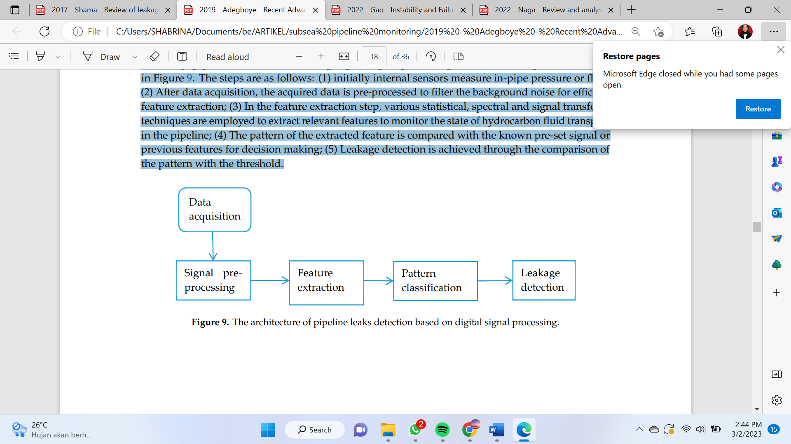

**Figure 5.** Illustration of the working stages of the digital signal processing method

The issue with this leak detection technique is that, unless the current life significantly improves the system response, only leak events—not actual leaks—can be found. Identification of leak responses from noisy data is made possible by digital signal processing. Although this leak detection method was initially suggested for liquid pipelines, gas pipelines are also being evaluated for its use. The main objective of this approach is to extract leakage information from noisy data; it does not require a mathematical pipe model. Similar to the statistical method, a leak that was already in the system before setup will never be found unless it gets bigger. Furthermore, this leak detection method is difficult to develop, retrofit, and test in addition to being expensive [12].

* + 1. Real-time transient monitoring/Dynamic Modelling

Dynamic modeling-based systems for detecting pipe leaks are receiving more interest as they have demonstrated effectiveness in identifying irregularities in both surface and subsea piping networks. This method involves creating a mathematical representation of the pipe system’s operation grounded in physical laws. Leak detection through this approach can be viewed from two perspectives: (1) a statistical perspective and (2) a transient perspective. From a statistical perspective, the system employs decision-making theory under the assumption that fluid flow parameters remain unchanged except in the presence of anomalies within the pipe. Leak detection through hypothesis testing relies on uncompensated mass balance derived from single or multiple measurements taken at various times.

Initial limit values ​​are defined by pressure, flow, and pipe temperature measurements. Computers connected to control and data collection (SCADA) use data to detect leaks. In this method, the hydraulic equations are solved, and they are 1) Conservation of mass. 2) Conservation of momentum. 3) Energy conservation. 4) Equation of state for fluids. RTTM considers the pipe configuration and product characteristics due to the number of parameters that can be processed. RTTM also detects leaks quickly because it continuously analyzes the pipe's condition. However, due to the large number of parameters in RTTM, it is a very complex way to detect leaks. In addition to its complexity, it is costly to set up because it requires many instruments, controller training, and maintenance. In addition, errors in instrument calibration can give rise to false alarms[3].

Nevertheless, the advancement of methods remains ongoing. A significant challenge to implementing this mechanical method is the absence of actual leak data to train the model, despite its promising capabilities for the early identification of pipe issues. A model has been created that employs Bayesian networks to assess the probability of pipe failures under conditions of uncertainty, recognizing that leaks or damage can result from the interplay of multiple factors and their relationships. The primary benefit of Bayesian networks lies in their capacity to incorporate both subjective insights and objective information in cases where prior data might be unreliable or lacking. According to Spandonidis et al. (2022), long short-term memory autoencoder (LSTM AE) models offer an unsupervised approach to detecting leaks, capable of pinpointing anomalies harmful to pipe systems; however, they also risk generating false negatives.

1. **Result And Discussion**

This section presents a qualitative evaluation of the effectiveness of different pipeline leak detection techniques, drawing from the prior literature and the recommendations established by the American Petroleum Institute (API). Performance evaluations were carried out based on several criteria, including cost, sensitivity, accuracy, leak detection precision, operational mode, user-friendliness, estimated leak size, ease of retrofitting, and the rate of false alarms. The assessment employed two- and three-tier performance comparisons, with bar graphs depicted in Figure 10. Generally, most methods incur substantial operational expenses, with the exception of vapor sampling, which has low operational costs; nevertheless, it suffers from a high rate of false alarms. All methods demonstrated good sensitivity, except for IRT, GPR, and NPW. Most techniques exhibited a considerable occurrence of false alarms. The dynamic modeling approach shows excellent sensitivity for identifying pipeline leaks, but its complexity and the need for skilled personnel present significant obstacles. Recent developments in high-performance computing and cloud computing technologies could increase the adoption of dynamic modeling approaches in the oil and gas industry.

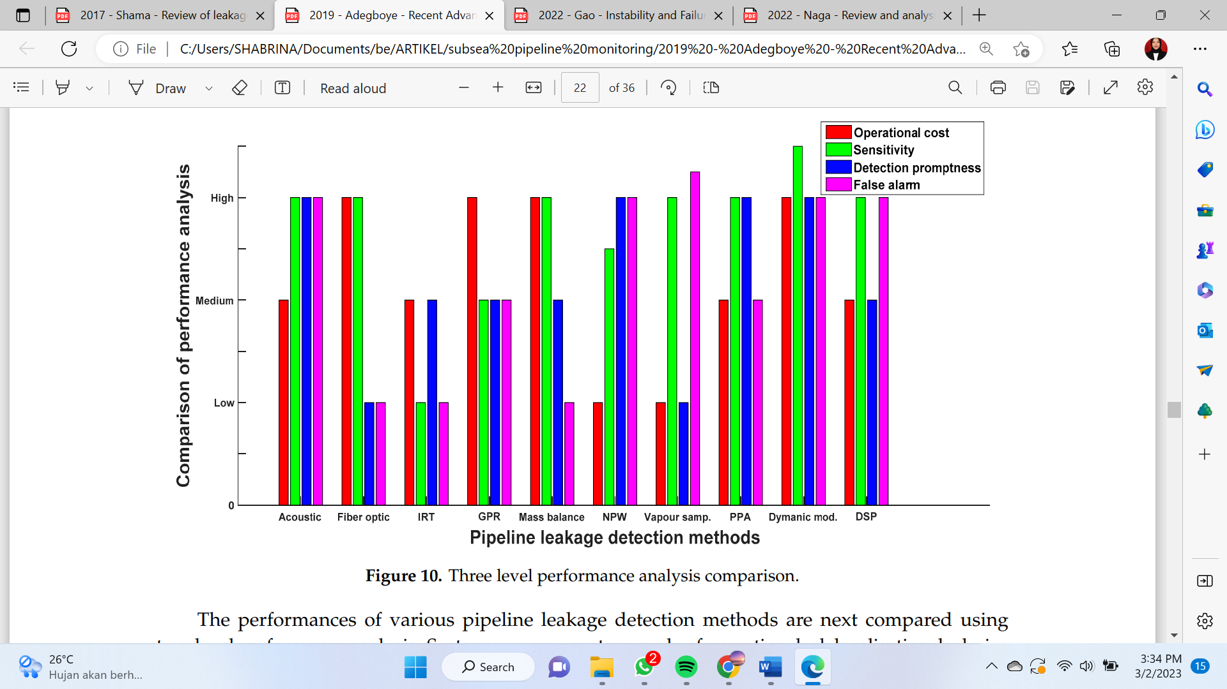

**Figure 6.** Comparative analysis of leak detection methods in pipes

Various external methods can accurately detect and locate leaks, but they must assess the magnitude of the leak. The acoustic method is reliable for identifying and tracking leaks in gas pipelines. While fiber optic detection techniques, such as DTS and DAS, require little maintenance once installed, the upfront cost for new piping is considerably higher than other on-site methods. Typically, external leak detection methods—except for acoustic ones—are utilized to find and pinpoint leaks in onshore pipelines, and currently, there are no sealing options for fiber optic sensors and signal amplifiers in subsea environments (Behar et al., 2020). Acoustic methods are viewed as the most effective for examining underwater pipelines and spotting leaks since even minor leaks create gas bubbles that emit clear acoustic signals [11]. External methods are widely employed to detect leaks in natural gas pipelines, especially in limited sections situated in sensitive regions, because of the significant capital investment needed to install sensors and fiber optic systems along the entire pipeline.

On the other hand, methods for monitoring internal or computational flow parameters provide benefits for assessing leak rates, assuming that the pipe instruments are calibrated correctly. Internal and computational techniques fulfill the requirements for both onshore and offshore pipelines, particularly the RTTM method combined with statistical analysis, which is exceptionally effective at identifying and pinpointing chronic leaks in subsea pipelines that transport multiphase petroleum and natural gas. Since various types of crude oil are typically sent through pipelines in distinct batches, RTTM with batch tracking facilitates the detection of discrepancies in pressure and flow. NPW technology is especially adept at detecting major leaks, typically those that represent 10% or more of the maximum flow rate; however, the normal pressure fluctuations from pump and valve operations can make it difficult to accurately identify and locate leaks, as they may produce pressure transients that could lead to the incorrect interpretation of leak occurrences (Yang and Zhao, 2022). Nevertheless, this approach often generates a significant number of false alarms during low fluid flow rates or in cases involving multiple leaks (The Closet et al., 2022). The use of internal/computational techniques is common in transmission pipelines for crude oil, refined oil, and natural gas, as it allows for the remote monitoring of irregularities; systems that incorporate mathematical modeling and flow parameter analysis within a SCADA framework can provide vital information necessary for effectively detecting the size and location of leaks.

Dynamic modeling has seen a notable increase in popularity recently, with applications spanning numerous industries, such as monitoring potential breakdowns in factory machinery and detecting leaks in pipes. A key obstacle in effectively applying machine learning for leak detection in the oil and gas industry is the scarcity of available leak data for the purpose of training and validating models. To tackle this challenge, several researchers have concentrated on generating synthetic data to act as input for model training and testing. Additionally, machine learning techniques are frequently utilized with data sourced from sensor devices used in both external and measurement-oriented methods, as well as from internal or computational approaches. Generally, the future aim of pipeline monitoring is to create real-time intelligent systems for detecting and pinpointing leaks in subsea pipeline networks. The influence of environmental factors, especially hydrodynamic forces induced by oblique waves and current loads on subsea pipelines, requires further investigation. Comprehensive laboratory studies and simulations are being carried out to explore how leak characteristics, such as dimensions and shapes, influence flow mechanisms and to validate different models. The numerical simulation of fluid behavior in pipes using computational fluid dynamics (CFD) has improved the understanding of internal flow and leak scenarios in pipes across various scales, which has led to a decrease in expenses related to experimental work. However, the considerable computational complexity tied to CFD persists as a major hurdle. Continued research is crucial to enhance and parallelize CFD solution algorithms, considering limitations in computing and memory resources.

The field of inspection methodologies has always been a dynamic area of research. However, the increasing use of uncrewed vehicles for leak detection along pipeline routes has opened up new research opportunities. This includes exploring the potential for incorporating advanced sensor technologies and multispectral image classification to evaluate all types of pipeline defects, whether located onshore or offshore. Several inspection methods, such as flame ionization detectors, infrared cameras, ultrasonic leak detection, and optical remote sensing systems, are routinely utilized in distribution pipelines. These techniques can be mounted on UAVs and helicopters. Optical remote sensing has proven effective in detecting methane leaks in crude oil pipelines, while thermal imaging has skillfully revealed anomalies in offshore rigs and gathering pipelines through the use of an autonomous robot known as SWIMMER. In-pipeline inspections are also commonly conducted using intelligent pigs to identify irregularities or defects in various materials transported within the pipeline system.

1. **Conclusion**

Pipe leaks can be found using a variety of methods, each with pros and cons. While externally based approaches are generally more accurate in detecting leaks, they may require assistance in assessing the extent of the leak. However, although internal/computational approaches may have a greater false alarm rate, they can monitor flow parameters and determine leak rates. When it comes to examining submerged pipes and finding leaks, the acoustic method is seen to be the most effective. Every approach has advantages and disadvantages, and the choice of approach is influenced by a number of variables, including the pipeline's kind and location, cost, sensitivity, accuracy, and ease of use. Dynamic modeling techniques may become more common in the oil and gas sector as a result of recent developments in high-performance computing and cloud computing technology.

This section offers a qualitative evaluation of the effectiveness of various methods for detecting pipeline leaks, based on the previously mentioned literature and standards established by the American Petroleum Institute (API). A comparison was performed using a range of performance metrics, including cost, sensitivity, accuracy, leak detection capability, operational mode, ease of use, estimated leak volume, adaptability for retrofitting, and frequency of false alarms. The analysis implemented both two- and three-level performance comparisons, with results depicted in bar charts as seen in Figure 10. Most techniques involve considerable operational expenses, apart from vapor sampling, which has low operational costs; however, it is plagued by a high incidence of false alarms. All methods demonstrated robust sensitivity, apart from IRT, GPR, and NPW. The majority of approaches showed a significant occurrence of false alarms. The dynamic modeling method is particularly effective in detecting leaks in pipelines. However, its complexity and the need for qualified personnel present considerable challenges for its application. Recent advancements in high-performance computing and cloud technologies may increase the appeal of dynamic modeling approaches in the oil and gas industry.

**References**

[1] Du, F., Li, C., & Wang, W. (2023). Development of Subsea Pipeline Buckling, Corrosion and Leakage Monitoring. *Journal of Marine Science and Engineering*, *11*(1), 188.

[2] Diao, X., Chi, Z., Jiang, J., Mebarki, A., Ni, L., Wang, Z., & Hao, Y. (2020). Leak detection and location of flanged pipes: An integrated approach of principal component analysis and guided wave mode. *Safety Science*, *129*, 104809.

[3] Adegboye, M. A., Fung, W. K., & Karnik, A. (2019). Recent advances in pipeline monitoring and oil leakage detection technologies: Principles and approaches. *Sensors*, *19*(11), 2548.

[4] Geiger, G., Vogt, D., & Tetzner, R. (2006). State-of-the-art in leak detection and localization. *Oil Gas European Magazine*, *32*(4), 193.

[5] Xu, J., Nie, Z., Shan, F., Li, J., Luo, Y., Yuan, Q., & Chen, H. (2013). Leak detection methods overview and summary. In *ICPTT 2012: Better Pipeline Infrastructure for a Better Life* (pp. 1034-1050).

[6] Zhang, J., Hoffman, A., Murphy, K., Lewis, J., & Twomey, M. (2013, April). Review of pipeline leak detection technologies. In *PSIG Annual Meeting*. OnePetro.

[7] Korlapati, N. V. S., Khan, F., Noor, Q., Mirza, S., & Vaddiraju, S. (2022). Review and analysis of pipeline leak detection methods. *Journal of Pipeline Science and Engineering*, 100074.

[8] Kousiopoulos, G.-.P., Kampelopoulos, D., Karagiorgos, N., Papastavrou, G.-.N., Konstantakos, V., Nikolaidis, S., 2022. Acoustic leak localization method for pipelines in high noise environment using time-frequency signal segmentation. IEEE Trans. Instrument. Meas. 71. doi:10.1109/TIM.2022.3150864.

[9] Geiger, G.; Vogt, D.; Tetzner, R. State-of-the-art in leak detection and localization. Oil Gas Eur. Mag. 2006, 32, 1–26.

[10] Scott, S.L.; Barrufet, M.A. Worldwide Assessment of Industry Leak Detection Capabilities for Single&MultiphasPipelines.OffshoreTechnologyResearchCenterCollegeStation.2003.Availableonline:http://citeseerx.ist.psu.edu/viewdoc/download?doi=10.1.1.118.6455&rep=rep1&type=pdf (accessed on 17 December 2018).

[11] Martins, J.C.; Seleghim, P. Assessment of the performance of acoustic and mass balance methods for leak detection in pipelines for transporting liquids. J. Fluids Eng. 2010, 132, 011401–011413.

[12] Shama, A. M., Bady, A., El-Shaib, M. N., & Kotb, M. A. (2017, October). Review of leakage detection methods for the subsea pipeline. In *Proceedings of the 17th International Congress of the International Maritime Association of the Mediterranean, Lisbon, Portugal* (pp. 9-11).

[13] Peng, Z.; Wang, J.; Han, X. A study of harmful pressure wave method based on HAAR wavelet transform in ship piping leakage detection system. In Proceedings of the 2011 IEEE 2nd International Conference on Computing, Control and Industrial Engineering (CCIE), Wuhan, China, 20–21 August 2011; IEEE: Piscataway, NJ, USA, 2011; pp. 111–113.

[14] Yonghong, S.; Zhenhua, W. Detection of small leakage from pipeline based on improved harmonic wavelet. Proceedings of the 2012 7th International Conference on Computer Science & Education (ICCSE), Melbourne, VIC, Australia, 14–17 July 2012; IEEE: Piscataway, NJ, USA, 2012; pp. 45–49.

[15] Chen, Z.; Lian, X.; Yu, Z. Leakage detection for oil pipelines based on Independent Component Analysis. Proceedings of the 29th Chinese Control Conference (CCC), Beijing, China, 29–31 July 2010; IEEE: Piscataway, NJ, USA, 2010; pp. 4009–4013.

[16] Li, Q.; Li, M.; Zhang, X.; Ba, W. Research on mixed signal separation method for pipeline leakage based on RobustICA. In Proceedings of the 2016 International Conference on Robotics and Automation Engineering (ICRAE), Jeju, South Korea, 27–29 August 2016; IEEE: Piscataway, NJ, USA, 2016; pp. 70–74.

[17] Li, H.; Xiao, D.; Zhao, X. Morphological filtering assisted field-pipeline small leakage detection. In Proceedings of the 2009 IEEE International Conference on System, Man and Cybernetics, SMC 2009, San Antonio, TX, USA, 11–14 October 2009; pp. 3769–3774.

[18] Zhang, G.; Zhu, J.; Song, Y.; Peng, C.; Song, G. A Time Reversal Based Pipeline Leakage Localization Method with the Adjustable Resolution. IEEE Access 2018, 6, 26993–27000.

[19] Fu, H., Ling, K., Pu, H., 2022. Identifying two-point leakages in parallel pipelines based on flow parameter analysis. J. Pipeline Sci. Eng. 100052.

[20] Meng, Q., Lang, X., Lin, M., Cai, Z., Zheng, H., Song, H., et al., 2022. Leak localization of gas pipeline based on the combination of EEMD and cross-spectrum analysis. IEEE Trans. Instrum. Meas. 71.

[21] Zheng, J., Liang, Y., Xu, N., Wang, B., Zheng, T., Li, Z., et al., 2021. Deep Pipe: a customized generative model for estimations of liquid pipeline leakage parameters. Comput. Chem. Eng. 149. doi:10.1016/j.compchemeng.2021.107

[22] Hassan, S., Wang, J., Kontovas, C., Bashir, M., 2022. An assessment of causes and failure likelihood of cross-country pipelines under uncertainty using Bayesian networks. Reliab. Eng. Syst. Saf. 218. doi:10.1016/j.ress.2021.108171.

[23] Spandonidis, C., Theodoropoulos, P., Giannopoulos, F., Galiatsatos, N., Petsa, A., 2022. Evaluating deep learning approaches for oil and gas pipeline leak detection using wireless sensor networks. Eng. Appl. Artif. Intel. 113, 104890. doi:10.1016/j.engappai.2022.104890

[24] Behari, N., Sheriff, M. Z., Rahman, M. A., Nounou, M., Hassan, I., & Nounou, H. (2020). Chronic leak detection for single and multiphase flow: A critical review on onshore and offshore subsea and arctic conditions. *Journal of Natural Gas Science and Engineering*, *81*, 103460.

[25] Yang, L., & Zhao, Q. (2021). A BiLSTM-based pipeline leak detection and disturbance-assisted localization method. *IEEE Sensors Journal*, *22*(1), 611-620.

[26] Sekhavati, J., Hashemabadi, S.H., Soroush, M., 2022. Computational methods for pipeline leakage detection and localization: a review and comparative study. J. Loss Prev. Process Ind. 77, 104771. doi:10.1016/j.jlp.2022.104771.